**Chapter 37 – Mae’s jobs in Layton, SOS Temporary Services, Head Secretary at Lincoln Elementary and then Secretary at Davis School District for the Staff Development Department.**

I could see a need to bring in some additional income with our boys planning to go on missions and Mike would be leaving soon, and also as I said before, that I couldn’t stand to be with Ken’s mom all the time. So, **I got a job at S.O.S. Temporary Service** doing receptionist and secretarial work. That was good experience for me and I was able to learn many programs on the computer which helped me get my job as Head Secretary at Lincoln Elementary in Layton.

The first place SOS sent me to was to **Layton City. I was to fill in for the Administrative Secretary** who just had her first baby. I was to work six weeks. I was the secretary to the mayor and city manager. I had a beautiful desk and work area and made many friends there and really enjoyed the work. Joan decided not to return to work so they offered me her job. I talked to Ken and he didn’t want me to work fulltime, so I turned it down. They asked me to stay on until they hired someone. It was a long process and finally they thought they hired the “perfect” secretary. (At least that’s what I thought they must be looking for, with all the tests and interviews they put those women through.) **The Chief of Police asked me to substitute for his secretary who would be gone for a while.** One day as I was working there, he came in with the City Manager. Bruce. Bruce asked if I would come back to the main office as they needed me more there as their “perfect secretary” had quit. I asked why she quit and he said: “She told us it was too stressful, that we needed to hire another person just to answer the phones, as she wasn’t able to get anything done with the phones ringing so much, and the stress was too much for her.” It was funny because every so often Bruce would stick his head out of his office and say **“Mae, is the stress getting to you, are you too stressed?” and we would laugh.** It was stressful, but I could handle it. When they finally hired another secretary, **the legal office asked me to fill in for their secretary who was also having a baby.** This was more stressful than the administrative secretary. I was secretary for the city attorney and the city lawyer (not sure what the difference was, but two different lawyers.) They talked into a Dictaphone and I was to type it up. They used such big words and I had trouble spelling them. I ran the office while they were away, I took papers to the court, made appointments, etc., etc. It was very busy and it was stressful, but I enjoyed it also.

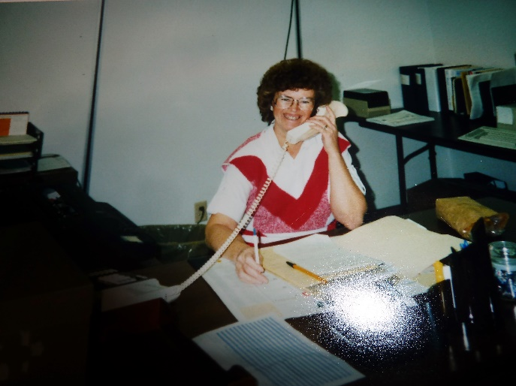SOS then sent me to **JetWay Systems** where I filled in for the receptionist – Wow! They had lots of lines that I had to connect people to. I had to memorize lots of numbers and people’s names. Lots of people came in and I directed them to different offices. It was beautiful there too and I enjoyed making friends there. I also substituted for different secretaries there. I had a 9-month contract with another office of JetWay Systems in a different building. I didn’t like it there as well, as the other secretary was Hispanic and for some reason she didn’t like me and was rude and ornery. I liked the boss, but he swore a lot and used bad language. He could tell I didn’t like it as I would cringe with some of the things he said. He tried harder not to use that language around me, but I could hear him in his office, as he talked to other people and on the phone. One day he called me in and gave me some other projects and then said “Did you know I was a Mormon?” I was shocked and said “No.” He started asking me questions about my family, background, etc., and found out that my maiden name was Porter and that I grew up in Sunset. He said “Porter! I live close to Verle Porter, is he any relative? I told him he was my uncle. He said Oh, I work with him in the High Priests and we do temple work together sometimes”. I was dumbfounded.

After that assignment, SOS sent me to **Kimberly Clark**. I filled in for several secretaries there also and ended up working there for several months. Just before Mike was to come home from his mission, they offered me a full-time job there. I enjoyed the work and had learned a lot and gained a lot of experience and made many friends. The facilities were beautiful, but I didn’t enjoy having to go so far to go to work, especially in the winter. I had a couple of frightening experiences skidding on the icy roads. I also wanted to have some time with Mike before he went off to college. With working for SOS, if I didn’t want to work all the time in the summer, I didn’t have to as they hired college students who were home for the summers. I talked to Ken and we decided to turn down this offer also. I was glad I did because I had always wanted to be an “Elementary school secretary”.

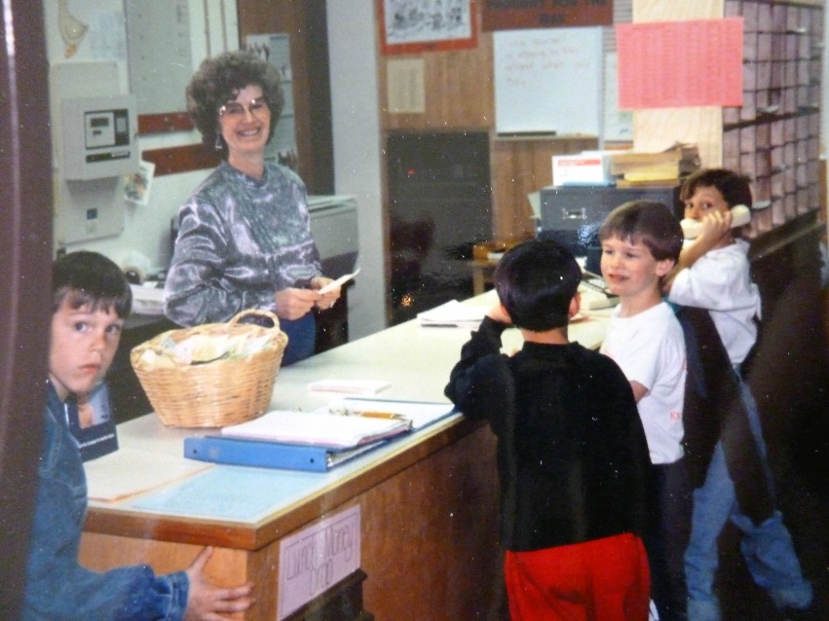My friend in the ward was a tutor at **Lincoln Elementary**, which was just a short walking distance away from Ken’s Mom’s home. She told me that the head secretary at Lincoln was going to the District Office and they were taking applications for that position now. I applied, was called in to interview with the **Principal, Sandy Petersen**, and the night before Mike and Becky’s wedding, Sandy called me to offer me the job. I hadn’t thought I would get the job as there were several who applied. I had gotten letters of recommendation from Joy, my boss at SOS, Dixie, the secretary over Human Services at Layton City, and a couple of secretaries at JetWay and Kimberly Clark. They were great letters so I’m sure that helped. Darlene, the previous secretary trained me for a couple of days and then she had to leave. She showed me two huge binders full of instructions that I could refer to. I felt overwhelmed as I looked through them. She told me I could call her when I had questions. The first week was awful. I was swamped with trying to help the teachers, the children, parents, the district office, the principal and vice principal and trying to learn my job. I came early, worked through my lunch hour, and stayed late. But it didn’t seem to help as there were always teachers in my office asking me for help before school and after school, and children, parents and teachers in during my lunch hour, so I finally decided I had to take some time to eat, so sometimes I went home just to have a break. Ken’s mom was cute to fix me a sandwich before I got there so I could have time to relax a little as she could see how stressful it was for me. One of the male teachers, who was older and about ready to retire, said to me one day “It looks like you have bit off more than you can chew.” Sandy had asked me in the interview if I could handle stress because it would be very stressful out in the front office. I told her I liked a challenge and I could handle stress and I told her about my jobs with SOS. Well, I thought I knew what stress was, but guess not. After a week or so, I was so overwhelmed that I talked to Ken and we decided that I should quit. **That morning when I went to school and was going to talk to Sandy and tell her I would be quitting, there was a beautiful floral arrangement on my desk with a card from Sandy saying she appreciated all I was doing and she was very thankful she had me for her secretary. She said how kind, friendly and helpful I was to all who came into the school and into our office. Well, how could I quit now?** I didn’t and I was happy I hadn’t. I learned line upon line and with the help of my three assistants (playground and office assistants) we were able to get the work done. I learned to love the teachers, parents, children and especially Sandy. Sandy was an exceptional boss and friend. I was so blessed to have her as my principal. Lincoln Elementary was a year-round school with 1000 students. Lincoln Elementary was located on Antelope and just below Hill Field Road. I worked there from October 1990 to August 1995. Maybe I should have taken the job with Layton City as their Administrative Secretary as it would have been a great job and I would have made good money. But I had always wanted to be an Elementary School Secretary - so I was able to do that and I did love the children, principal, vice principle, teachers and most of the parents.

I had three great assistant secretaries. They did the playground duty during recess and the lunch break, 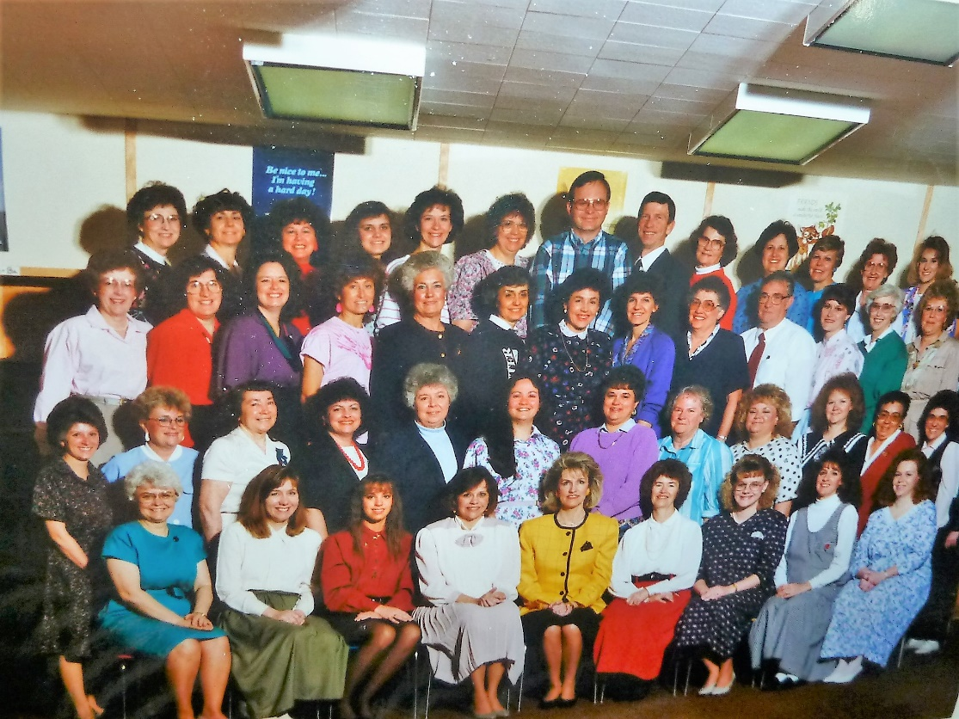but otherwise they were in the office helping me and helping those who came into the office, and they helped me answer the phones. **Gail Revett** was one assistant. She was a tiny little petite lady. (She is on the left side, second roll up in the picture.) She was married and lived in a nearby trailer court and had one son. She was very good at her job, but her and **Luanne Macfarlane** didn’t get along. They tried to compete for work in the office. Instead of one or the other being lazy, they were both very hard workers and very efficient, so that was great, but they didn’t get along. They were always coming to me about something the other was doing that they felt should be their job. They were jealous of each other, I think and very competitive. I thought a lot of each of them, but it was a headache for me to try to keep them happy. Luanne was our Bishop’s wife. (She is on the right, second row up, third one from the end, in the picture). **Lorraine Rirey** was the other assistant and she was a neat lady. I became friends with most of the teachers, and I liked all of them. (Lorraine wasn’t in this picture) **Nancy Mecham**, a 3rd grade teacher and I were walking buddies. (Nancy is sitting on the front row on the left in front of Gail Revett). Nancy and I would walk together each morning before school started. In the spring, summer and fall, we would walk outdoors, and in the winter, we would walk fast around the halls. She was a neat lady and as we talked, we got to know each other very well. (Nancy is on the first row, first on the left side in the picture.) A 6th grade teacher, Joan ?? and I enjoyed visiting together. **Claudia Thompson** was a 2nd grade teacher and a good friend, we were friends at Lincoln, and we lived in the same stake, so were counselors to Marge Beardall in the Stake Relief Society Presidency. Then when Ken & I moved to Clinton after our mission to the Philippines, Claudia & Wayne had moved to Clinton and “what a surprise”, there were in our ward. (She is on the 2nd row u and the 5th from the left side.) There were many I really admired and enjoyed being with. I don’t know any I didn’t like – I just liked some more than others. Val, Sandy’s husband was always coming into the school bringing flowers to Sandy or bringing her something for lunch. He was a neat guy. He and Sandy had bought a beautiful condo in St. George and Val suggested to Sandy that they let Ken and I stay in it for a get-a-way weekend vacation some time. She asked me if we would like to do that and when I asked Ken, he was excited. We really enjoyed it. They let us use it two different times. Val would bring me a drink sometimes when he would bring Sandy one. Sandy had flowers delivered to me many times and she gave me wonderful gifts for Christmas, my birthdays and Secretary Days, and took me and my assistants to lunch sometimes. She was always praising me, so of course, I tried to do my best and I loved working with her.

Sandy always gave me wonderful reviews each year and she nominated me to receive the secretary of the year award in 1992. The superintendent presented these awards at the school board meeting. He said some nice things about me and then presented me with a plaque which read: “Davis County Schools extends honor and recognition to Iva Mae Browning, Secretary at Lincoln Elementary School for dedicated and outstanding service for the children of the Davis County Schools for 1992. It was signed by Dr. Richard Kendell, Superintendent of Schools and Lynn Summerhays, President of the Board of Education

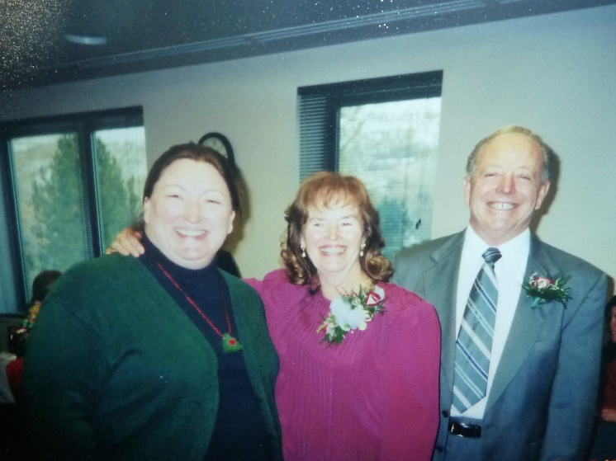 After two years, the people over Job Core talked Sandy into coming to work for them, being over their educational dept. She talked to the superintendent about it and they ask her to be on a “leave of absence” so if the job didn’t work out or she didn’t enjoy it, she could come back and work for the district again. We were all sad that she would be leaving Lincoln Elementary as we all loved her. She worked for a year and even though the pay was great, she wanted to come back to the district. She got a principal position at Layton Elementary. Her principal position at Lincoln had, of course, been filled by Richard Baird. He was an “ok” principal, but he sure wasn’t near as good as Sandy. The faculty, parents and children knew that as well as I. I was there three years with him. **Jody Schaap** was the first assistant principal to Sandy and she was great too, and then she got a position as principal at another elementary school. (Jody is in this picture with Ken & I). Another vice principal was hired at Lincoln. She was a different lady, but I liked her too. Susan (I can’t remember her last name now.)

**I am now the secretary at Staff Development at Davis School District in Farmington, Utah**

I was talking to Sandy Petersen and asked how she liked her job at Davis School District. She told me she really liked it and liked the people she worked with. She told me that I should come to the district also. I told her that I would if I could be her secretary again. She told me that the secretary of Staff Development was quitting and I should apply for it. Sandy worked in Staff Development. She was the liaison between the district and the University of Utah. I loved working at Lincoln Elementary, but felt I needed a change, especially if I could work with Sandy. I applied and was called in for an interview. When I arrived, I was surprised and intimated to see that there were 8 people around the large table in the conference room who would be interviewing me. Claudia Seeley, the Staff Development Director, the director of Curriculum, Sandy Petersen, and others (I don’t remember their names) They asked me all kinds of questions and even though I was nervous, I must have done okay as then they had me go in another office and take both a written and computer test. They told me they would call and let me know after they had finished the interviews. They called and I was hired, but then I had mixed emotions as I was nervous about starting another job and I would have to travel further and I did feel bad about leaving Lincoln.

When I started working, I had a desk, with several other secretaries who worked for the Curriculum department. I was told that we should not let the phones keep ringing, that if the other secretaries were on their phones or away from their desk, that I should answer their phones and take messages. This was hard as many calls for Staff Development kept coming in, so 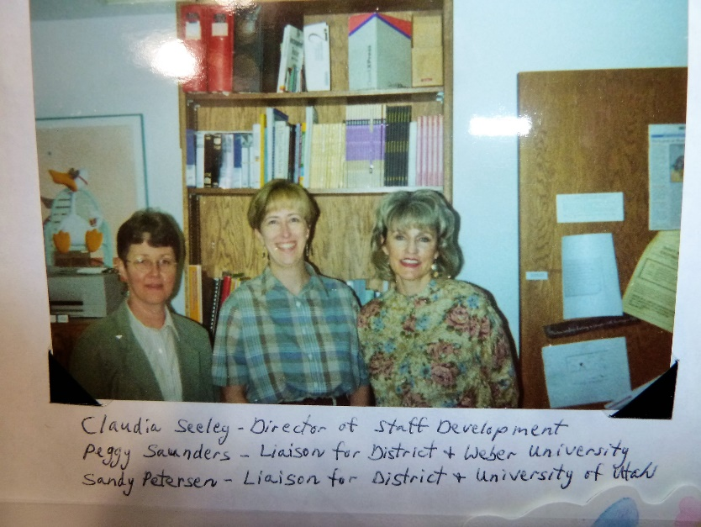between helping principals, vice principals, teachers and other people from the district, who needed my help or needed to talk to **Claudia, Sandi or Peggy**, I had to answer their calls and take messages. I also found out that the reason the former secretary quit was because she felt this job was too stressful, so she applied for a job in another department. I found out from the other secretaries and later from Claudia, that this secretary didn’t do her work that she just visited with the other secretaries and took time off work. I called her to ask her if she would come and train me and I had a hard time pinning her down to a day and time, but finally she came. She didn’t stay long as she said it was just too stressful for her and gave her anxiety. She wasn’t any help, so I just had to learn by reading information and asking Claudia and others. I felt like I had jumped from the frying pan into the fire. It was hard at Lincoln, but at least Darlene had trained me for a couple of days and I could call her at the district when I had questions. I got lots of calls from angry teachers who were supposed to get their “lane changes” (raises) and they hadn’t gotten them because the classes they had taken were not recorded. I saw a box of receipts on top of the filing cabinet. These were to be recorded and filed, but they were not. I was frustrated that I didn’t have the time to get out information to the schools and teachers by mail so I asked Claudia if I could get a neighbor of mine to do this for me and if the district could pay her. Claudia understood how hard it was for me, so she agreed and I found a neighbor to do this and this helped.

There was a small room next to Claudia’s office and close to Sandi & Peggy’s office that had been used for a copy room. There was a copier in there, paper, boxes, file cabinets, etc. The district remodeled and made a larger copy room for both Staff Development and Curriculum to use, so they discontinued using this small room. I had a good idea and approached Claudia about moving my desk & file cabinet to this room when I would just answer our phones and could have more time to do my work. She agreed and I was moved. I had a chair sat by my desk where when teachers or others came, they could sit there and I could help them. This worked so much better. There wasn’t a window in this room, but that was better for me as it was more private and I could keep my door open and the office across from me had a window and Greg was gone a lot,

but would leave his door open for me. I would come early, work through my lunch hour and work late to try to get the work caught up from how the former secretary left it to me. Claudia told me that when she quit getting angry phone calls, she would go out and celebrate. I think she was about ready to fire that girl (can’t remember her name) and the girl knew it, so quit. She wanted to anyway as she had let the work go so long that she was getting angry phone calls too.

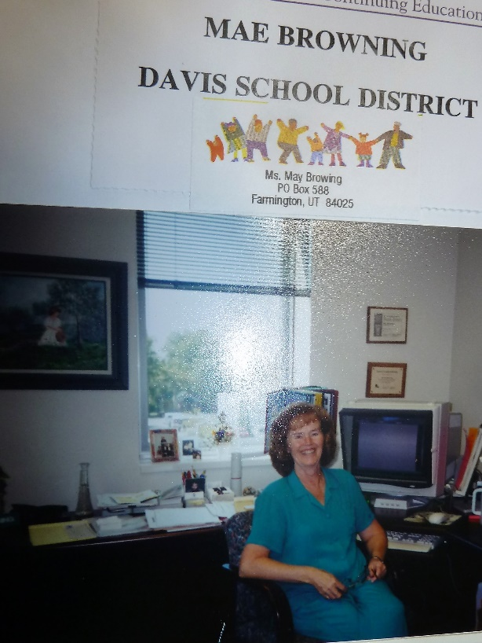Ken was concerned as he was afraid the stress would cause health problems for me, so he tried to think of ways to help me and simplify my work. He did really help me. Ken came up with an excellent filing system and helped me get it set up. That was a big help. Also, Claudia was able to get funding from the district to hire a part-time assistant secretary for me. Patti was working part-time for the Curriculum Dept and she wanted full time work, so she applied for this position and was hired. I thought she would be a great help, but actually she was another frustration for me. She was so social that she kept visiting with the other secretaries and other staff that she wasn’t a lot of help. But I was finally able to get the work caught up and able to help the teachers as they called or came in. Claudia was really happy, and her and I had a great relationship. **Claudia was getting close to retirement and the district was building another beautiful building just adjacent to the main building, and Claudia was in on the planning of it. She planned out a beautiful area for Staff Development and had a wonderful area for me with a beautiful desk and everything I needed. We were on the second floor. Claudia retired and Sandy applied for this position and got it. I was excited as I knew she would be wonderful and I loved working for her.**

Patti wanted to work full time for just one department so she applied and got the secretary position at the planning department, which was also in this building. I was happy that she was gone. We hired another girl to take Patti’s place and she was good, but soon applied for full time at the transportation dept and got that job. We had the funds now to hire a full-time Receptionist/assistant secretary and we hired another girl. She was great at technology, but not so great at doing the work she needed to do, so she was another frustration. She was always calling in sick at the last minute and I would have to do her work as well as mine. This happened so often, that one day as I was sitting at her desk and crying because it was too much, Sandy came out of her office and when she saw me crying, she was very concerned and asked me what the problem was. When I told her, she was angry and said she would take care of it. I told her “no” that I would work with her a little longer. Her husband was usually the one who called to say she was sick. She quit, thank goodness as she knew she was on the brink of getting fired, and she was pregnant and didn’t want to work.

Sandy and I were mainly the ones to interview and hire another Receptionist/Secretary and we had many applicants. We interviewed about 6 and we narrowed it down to two. Sandy kind of leaned to the one as she was younger than Billie, had more experience, and was more social. Billie was a little shy, but I felt good about her. Sandy had to go out of town and she said she would leave it up to me and I could hire the one I wanted. I was excited about that and hired the older one, **Billie Ririe.** She turned out to be fantastic! She was so dependable, efficient, kind and courteous on the phone and when people came into our department. She was always on top of everything and she came early to work and would stay later if it was needed. Billie was a widow, who was living in the basement with her daughter, in her son’s home. Her daughter was single and worked as a custodian for the school district. The Lord really blessed me to have Billie as my assistant – now I loved my job and everyone I worked with in this department. When we were not busy, we visited, laughed and helped each other. Since we have both retired, we still keep in touch by e-mail, phone and mail. I have gone to visit her couple of times too. She is special. I worked for the district seven years so my total years were twelve.

One of my responsibilities was to put out a monthly catalogue with all the classes which Staff Development was offering. This took a lot of time, but I enjoyed doing this too. The teachers took these classes as requirements to get their lane changes. I also ordered food for many of our meetings. Sometime I had them catered by Food Services, sometimes other restaurants and sometimes I would go get food and get it ready, I especially did this for continental breakfasts.

When Sandy became the Staff Development Manager, they hired **Betty Spencer** to take her place as the liaison between the district and the University of Utah. **Peggy Saunders** was the liaison between the district and Weber State University. Marilyn Junk worked part time for Curriculum and part-time for Staff Development, but her office was in the Curriculum Dept. Peggy was let go (I can’t remember why but she was unhappy about that. I was sad too as we had become good friends. – probably politics in the District). **Christy Blanch,** the former principal of Fairfield Junior High School took her place. Christy was really smart, especially 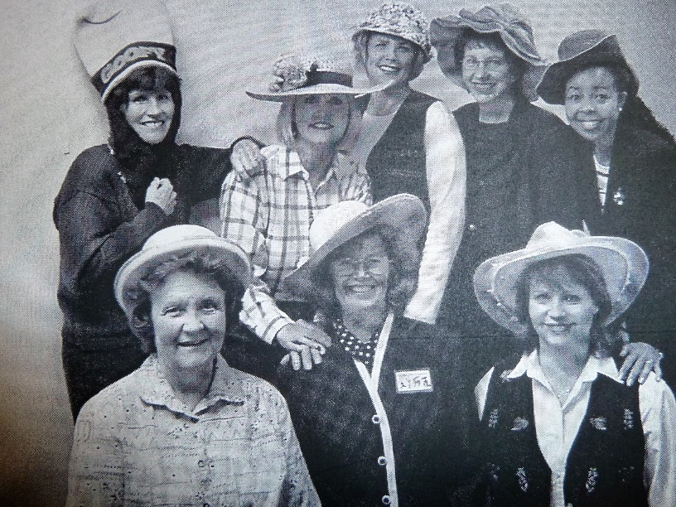with technology, but she got brain cancer, was operated on and was never the same and died soon after. (Back row, left to right, in this picture is: Marilyn Junk, Dr. Sandy Petersen, Ann, Betty Spencer & Jackie Thompson. Billie, Mae & Linda on the front row.)

Later, as the work and department continued to grow, we were able to hire another part-time assistant, **Linda Duffin**, who worked part time for Staff Development and part-time for the Curriculum Dept. Her office was in the Curriculum Dept. Linda was wonderful too and very dependable. She was a friendly, happy person and I loved her too.

**Jackie Thompson** was hired to take Christy’s place. Jackie is African American and also very smart, but also very sweet. I was not only Sandy’s secretary, but the secretary for Betty and Jackie as well. Jackie and I became great friends, even though she was one of my bosses, and we would go walking and talking on our lunch hours when she didn’t have trainings, meetings, etc. Afterwards we would eat our lunches together in the break room. Jackie is very spiritual and has great family values so we enjoyed visiting as we walked and ate our lunch. We had such good talks that after I retired and returned home from our mission to the Philippines, I would call her and we would set up a day each month to get together on her lunch hour and again walk, talk and go to lunch. She scheduled an extra-long lunch hour for herself so we had plenty of time. We did this until Ken and I went on our California mission and when we returned, Jackie and I again met monthly for our walk, talk & lunch.

**I was able to retire in January 2003, just prior to Ken and I going on our mission to the Philippines.** Elizabeth, the secretary at the Computer Dept, took my job. I knew Elizabeth and knew she wanted to come to Staff Development, and I knew she would be very good, so I was happy when she got the job. She wasn’t hard to train.

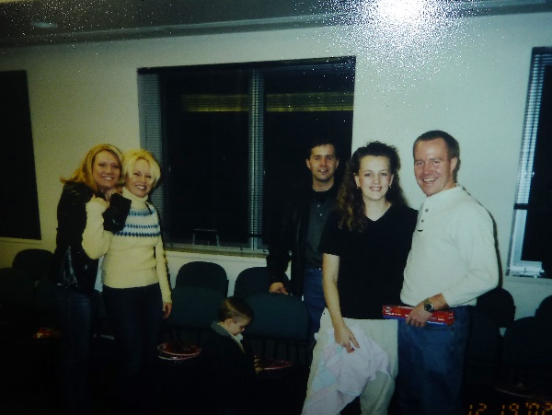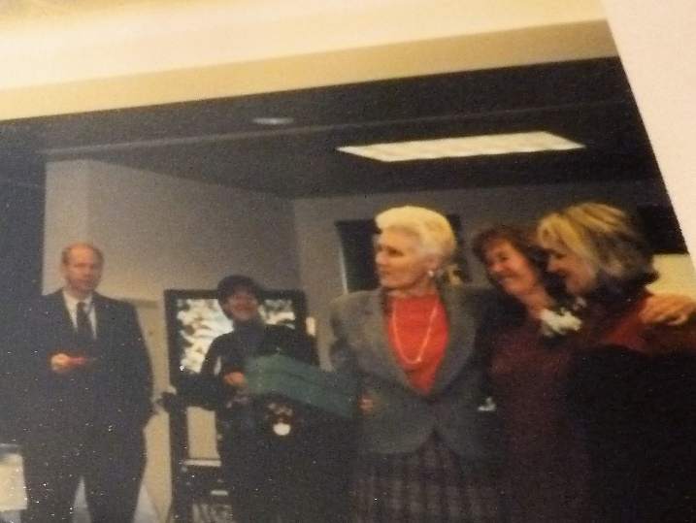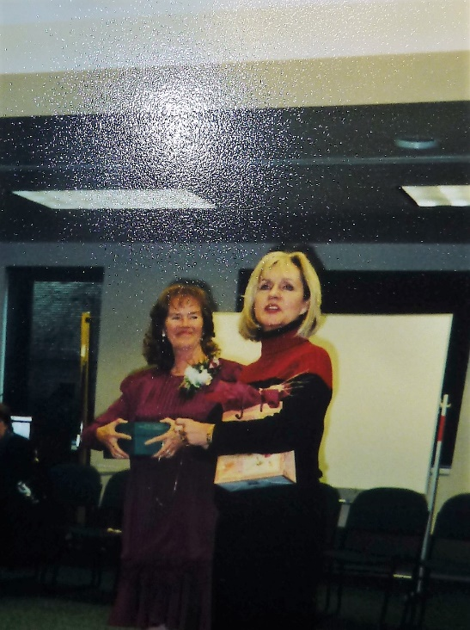**My boss, friend and Director of the Staff Development Dept, Sandy Petersen, and my assistants planned a retirement open house for me in January 2003.** They went all out and it was really nice. They sent invitations out to all the schools and district offices and to our family. Most of our children and grandchildren were there and many of my friends from the schools and district office. Sandy and my assistants gave me a beautiful corsage to wear. The school catering dept catered the food and it was really nice**.**

**Nancy Fleming the assistant superintendent over Staff Development made a speech and presented me with a beautiful gold bell. Sandy made a speech and gave me gifts**. They had me say a few words. I received many cards and gifts. I was afraid that not many would attend and I had kind of wanted to not have an open house, but just slip quietly away – maybe do a lunch with the ladies in our department instead, but that didn’t happen. **Also, my former boss, Claudia Seeley, gave me a going away party at her home in Salt Lake and invited our Staff Development Dept -** Sandy, Marilyn, Betty, Jackie, Billie, Linda and myself. Claudia had a nice lunch for us and they all went in on a gift for me. It was a Christmas Angel. We had a great time. My other secretary friends, at the district office, also took me out to lunch one day before I left. I am happy to retire and be able to go on a mission with Ken, and on returning, to have more time with family and do other things I have wanted to do, but I will miss these good friends that I have worked for and with.

**Sandi and Val Petersen,** my former boss, along with her husband, from Staff Development at the district **came to our Sacrament Meeting where Ken and I reported our mission. After the meeting, I spoke to Sandi and she encouraged me to come back and work again at the district. She said she had just the position for me**. I wondered if it was to be her secretary again. She is the Assistant Superintendent. I declined as I really want to have time now to enjoy my family and have time to visit and travel, etc. Now, in retrospect, maybe I should have gone back to work for her, as we would have been in better shape, financially